1. Write a SELECT statement that joins the Categories table to the Products table and returns these columns: CategoryName, ProductName, ListPrice.

Sort the result set by CategoryName and then by ProductName in ascending order.

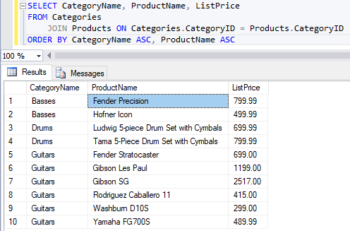

2. Write a SELECT statement that joins the Customers table to the Addresses table and returns these columns: FirstName, LastName, Line1, City, State, ZipCode.

Return one row for each address for the customer with an email address of allan.sherwood@yahoo.com.

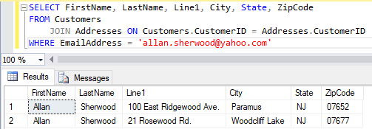

3. Write a SELECT statement that joins the Customers table to the Addresses table and returns these columns: FirstName, LastName, Line1, City, State, ZipCode.

Return one row for each customer, but only return addresses that are the shipping address for a customer.

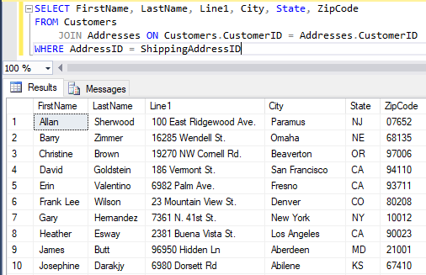

4. Write a SELECT statement that joins the Customers, Orders, OrderItems, and Products tables. This statement should return these columns: LastName, FirstName, OrderDate, ProductName, ItemPrice, DiscountAmount, and Quantity.

Use aliases for the tables.

Sort the final result set by LastName, OrderDate, and ProductName.

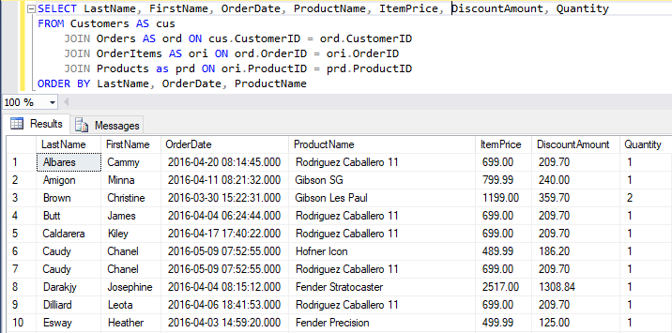

5. Write a SELECT statement that returns the ProductName and ListPrice columns from the Products table.

Return one row for each product that has the same list price as another product. *(Hint: Use a self-join to check that the ProductID columns aren’t equal but the ListPrice column is equal.)*

Sort the result set by ProductName.

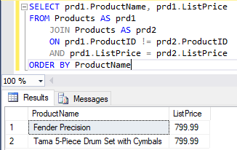

6. Write a SELECT statement that returns these two columns:

CategoryName The CategoryName column from the Categories table

ProductID The ProductID column from the Products table

Return one row for each category that has never been used. *(Hint: Use an outer join and only return rows where the ProductID column contains a null value.)*

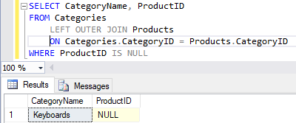

7. Use the UNION operator to generate a result set consisting of three columns from the Orders table:

ShipStatus A calculated column that contains a value of SHIPPED or NOT SHIPPED

OrderID The OrderID column

OrderDate The OrderDate column

If the order has a value in the ShipDate column, the ShipStatus column should contain a value of SHIPPED. Otherwise, it should contain a value of NOT SHIPPED. Sort the final result set by OrderDate.

